Commemoration of ‘The Somme’

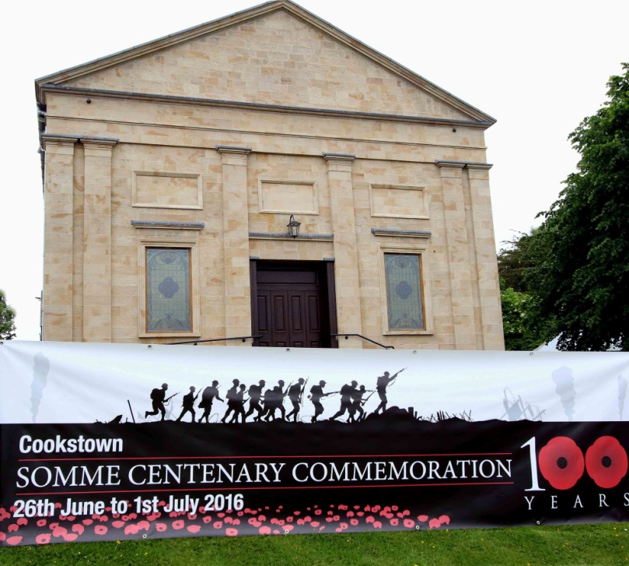

Sunday 26 June 2016
Commemoration of The Somme
Service at 3.30 pm in First Presbyterian Church Cookstown
Praise led by Tamlaghtmore Silver Band, conducted by Mrs Gael Haslett
Bugler: Mr Chris Donnelly
Poppy Garden to be officially opened by Her Majesty’s Lord Lieutenant;
Wreaths laid by HML and Chairman of The Mid Ulster District Council,
followed by afternoon tea in The Main Hall.
Monday—Thursday, 27-30 June 2016
10.00 am—4.00 pm: The Poppy Garden is open.
Anyone can lay a Poppy Cross and write a brief dedication on it.
7.00 pm—9.00 pm: Somme Exhibition in Minor Hall,
organised by The Mid Ulster Friends of the Somme Association.
7.30 pm—9.00 pm: Free refreshments in The Loft
8.00 pm: Brief Act of Remembrance at ‘The Poppy Garden’
Friday 1 July 2016
7.28 am: Act of Remembrance at Cookstown Cenotaph,
followed by a brief talk in our Main Hall on Tyrone Volunteers and the Great War by Mid Ulster Friends of the Somme Association,
a free breakfast will be served by the congregation’s catering team.
11.00 pm: Parade from Cookstown RBL to the Cenotaph for Act of Remembrance

